**Practical No. 4**

1. **Working with Node.js events and callback.**
2. **Callback**

**simple.txt**

This is simple text file

**Code:**

var file=require("fs");

var data=file.readFileSync('simple.txt');

console.log(data.toString());

console.log("Program ended");

**Output:**

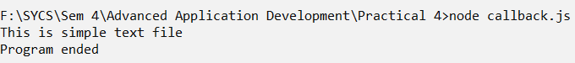

**Code:**

var file=require("fs");

file.readFile('simple.txt', function(err,data){

if(err) return console.error(err);

console.log(data.toString());

});

console.log("Program Ended")

**Output:**

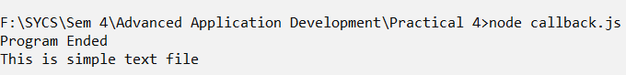

1. **Events**

**Code:**

//Import Event Module

var events=require('events');

//Create EventEmitter Object

var eventemitter=new events.EventEmitter();

//Define a Handler function to handle 'connection' event

var Handler=function connected()

{

console.log("Connection Established");

eventemitter.emit('download');

}

//Register download event with asynchronous function

eventemitter.on('download', function(){

console.log("File Downloaded")

});

//Bind connection event with Handler function

eventemitter.on('connection', Handler);

eventemitter.emit('connection');

console.log("Program Terminated")

**Output:**

